|  |  |  |  |  |  |  |  |  |  |
| --- | --- | --- | --- | --- | --- | --- | --- | --- | --- |
| I(mA) | ±ΔI(mA) | | Ia(mA) | | ±ΔIa(mA) | I-Ia(mA) | ±Δ(I-Ia) | Ia/R(mA/Ω) | ±Δ(Ia/R)(mA/Ω) |
| 27,6 | ±0,1mA | | 14 | | ±1mA | 13,6 | ±1,1mA | 28 | ±2mA/Ω |
| 30,7 | ±0,1mA | | 16 | | ±1mA | 14,7 | ±1,1mA | 32 | ±2mA/Ω |
| 34,2 | ±0,1mA | | 18 | | ±1mA | 16,2 | ±1,1mA | 36 | ±2mA/Ω |
| 36,9 | ±0,1mA | | 19 | | ±1mA | 17,9 | ±1,1mA | 38 | ±2mA/Ω |
| 42,8 | ±0,1mA | | 22 | | ±1mA | 20,8 | ±1,1mA | 44 | ±2mA/Ω |
| 44,9 | ±0,1mA | | 23 | | ±1mA | 21,9 | ±1,1mA | 46 | ±2mA/Ω |
| 48,9 | ±0,1mA | | 25 | | ±1mA | 23,9 | ±1,1mA | 50 | ±2mA/Ω |
| 52,6 | ±0,1mA | | 27 | | ±1mA | 25,6 | ±1,1mA | 54 | ±2mA/Ω |
| 58,4 | ±0,1mA | | 30 | | ±1mA | 28,4 | ±1,1mA | 60 | ±2mA/Ω |
| 64,5 | ±0,1mA | | 33 | | ±1mA | 31,5 | ±1,1mA | 66 | ±2mA/Ω |
| 69,7 | ±0,1mA | | 36 | | ±1mA | 33,7 | ±1,1mA | 72 | ±2mA/Ω |
| 74 | ±0,1mA | | 38 | | ±1mA | 36 | ±1,1mA | 76 | ±2mA/Ω |
| 79,9 | ±0,1mA | | 41 | | ±1mA | 38,9 | ±1,1mA | 82 | ±2mA/Ω |
| 84 | ±0,1mA | | 43 | | ±1mA | 41 | C:\Users\Juan\AppData\Local\Microsoft\Windows\INetCacheContent.Word\Captura.png±1,1mA | 86 | ±2mA/Ω |
| Ri(Ω) |  | ±ΔRi(Ω) | |  |
| 0,4857143 | ± | 0,07397959 | | Ω |
| 0,459375 | ± | 0,06308594 | | Ω |
| 0,45 | ± | 0,05555556 | | Ω |
| 0,4710526 | ± | 0,05373961 | | Ω |
| 0,4727273 | ± | 0,0464876 | | Ω |
| 0,476087 | ± | 0,04461248 | | Ω |
| 0,478 | ± | 0,04112 | | Ω |
| 0,4740741 | ± | 0,03792867 | | Ω |
| 0,4733333 | ± | 0,03411111 | | Ω |
| 0,4772727 | ± | 0,03112948 | | Ω |
| 0,4680556 | ± | 0,02827932 | | Ω |
| 0,4736842 | ± | 0,02693906 | | Ω |
| 0,4743902 | ± | 0,02498513 | | Ω |
| 0,4767442 | ± | 0,02387777 | | Ω |

**Medidas en corriente contínua**

Juan Casado Ballesteros

Trabajo experimental 1: Determinar la resistencia interna del miliamperímetro.

Trabajo experimental 2: Ampliación del fondo de escala del miliamperímetro.

|  |  |  |  |
| --- | --- | --- | --- |
| I(mA) | ±ΔI(mA) | Ia(mA) | ±ΔIa(mA) |
| 27,7 | ±0,1mA | 9 | ±1mA |
| 32,5 | ±0,1mA | 11 | ±1mA |
| 39,3 | ±0,1mA | 13 | ±1mA |
| 47,8 | ±0,1mA | 16 | ±1mA |
| 54,1 | ±0,1mA | 18 | ±1mA |
| 59,9 | ±0,1mA | 20 | ±1mA |
| 65,6 | ±0,1mA | 22 | ±1mA |
| 69,6 | ±0,1mA | 23 | ±1mA |
| 75 | ±0,1mA | 25 | ±1mA |
| 89,9 | ±0,1mA | 30 | ±1mA |

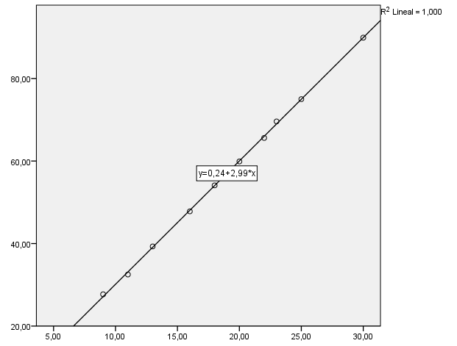

|  |  |  |  |
| --- | --- | --- | --- |
| Vab(V) | ±ΔVab(V) | Ia(mA) | ±ΔIa(mA) |
| 0,212 | ±0,001V | 2 | ±1mA |
| 0,291 | ±0,001V | 3 | ±1mA |
| 0,406 | ±0,001V | 4 | ±1mA |
| 0,502 | ±0,001V | 5 | ±1mA |
| 0,598 | ±0,001V | 6 | ±1mA |
| 0,702 | ±0,001V | 7 | ±1mA |
| 0,803 | ±0,001V | 8 | ±1mA |
| 0,912 | ±0,001V | 9 | ±1mA |
| 1,003 | ±0,001V | 10 | ±1mA |
| 1,199 | ±0,001V | 12 | ±1mA |

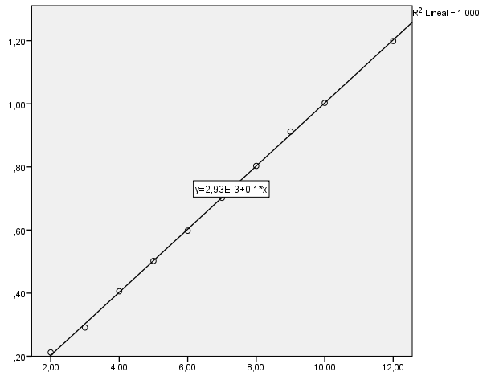

Trabajo experimental 3: Construcción de un voltímetro de 5 voltios de fondo de escala.

|  |  |  |  |  |  |  |  |
| --- | --- | --- | --- | --- | --- | --- | --- |
| Vac(V) | ±ΔVac(V) | Vab(V) | ±ΔVab(V) | Vbc(V) | ±ΔVbc(V) | Vab+Vbc(V) | ±Δvab+ΔVbc(V) |
| 12 | ±1V | 7 | ±1V | 7 | ±1V | 14 | ±2V |
| 13 | ±1V | 8 | ±1V | 8 | ±1V | 16 | ±2V |
| 17 | ±1V | 10 | ±1V | 10 | ±1V | 20 | ±2V |
| 19 | ±1V | 11 | ±1V | 11 | ±1V | 22 | ±2V |
| 21 | ±1V | 12 | ±1V | 12 | ±1V | 24 | ±2V |
| 23 | ±1V | 13 | ±1V | 13 | ±1V | 26 | ±2V |
| 27 | ±1V | 15 | ±1V | 15 | ±1V | 30 | ±2V |
| 29 | ±1V | 16 | ±1V | 16 | ±1V | 32 | ±2V |
| 36 | ±1V | 19 | ±1V | 19 | ±1V | 38 | ±2V |
| 41 | ±1V | 21 | ±1V | 21 | ±1V | 42 | ±2V |
|  |  |  |  |  |  |  |  |
| Vac(V) | ±ΔVac(V) | Vab(V) | ±ΔVab(V) | Vbc(V) | ±ΔVbc(V) | Vab+Vbc(V) | ±Δvab+ΔVbc(V) |
| 9,11 | ±0,01V | 4,54 | ±0,01V | 4,54 | ±0,01V | 9,08 | ±0,02V |
| 9,14 | ±0,01V | 4,55 | ±0,01V | 4,55 | ±0,01V | 9,1 | ±0,02V |
| 9,15 | ±0,01V | 4,56 | ±0,01V | 4,56 | ±0,01V | 9,12 | ±0,02V |
| 9,18 | ±0,01V | 4,57 | ±0,01V | 4,57 | ±0,01V | 9,14 | ±0,02V |
| 9,2 | ±0,01V | 4,58 | ±0,01V | 4,58 | ±0,01V | 9,16 | ±0,02V |
| 9,22 | ±0,01V | 4,59 | ±0,01V | 4,59 | ±0,01V | 9,18 | ±0,02V |
| 9,23 | ±0,01V | 4,6 | ±0,01V | 4,6 | ±0,01V | 9,2 | ±0,02V |
| 9,25 | ±0,01V | 4,61 | ±0,01V | 4,61 | ±0,01V | 9,22 | ±0,02V |
| 9,27 | ±0,01V | 4,62 | ±0,01V | 4,62 | ±0,01V | 9,24 | ±0,02V |

Trabajo experimental 4: Estudio del rango de utilidad para la medida del voltímetro construido.